Lab 4
Manual A* Heuristic Trace

1. Problem Setup
This solution follows Lab 4, Task 1 (page 18) and the supplied campus graph in Sections 4.2–4.5 (pages 17–18). The start node is S and the goal node is G. A* uses f(n) = g(n) + h(n), where g(n) is the cost from S to n and h(n) is the supplied estimate of the remaining cost.
Directed weighted graph: S → A (1), S → B (4), A → C (2), B → G (5), C → G (3). G has no outgoing edges.
Heuristic values: h(S)=5, h(A)=4, h(B)=4, h(C)=2, h(G)=0.
Queue convention: the frontier is ordered by the smallest f value first. Entries are shown as Node (g, h, f). The selected node is removed before its successors are added.

2. Initial Frontier
Initially only S is in the frontier. g(S)=0, h(S)=5, so f(S)=g+h=0+5=5. Initial frontier: S (g=0, h=5, f=5).

3. First Expansion: Select S
S is selected because it is the only frontier entry and has f(S)=5.
For A: g(A)=g(S)+cost(S,A)=0+1=1; h(A)=4; f(A)=1+4=5.
For B: g(B)=g(S)+cost(S,B)=0+4=4; h(B)=4; f(B)=4+4=8.
Frontier after expanding S: A (g=1, h=4, f=5), B (g=4, h=4, f=8).
Next node: A, because f(A)=5 is less than f(B)=8.

4. Second Expansion: Select A
A is selected because f(A)=5 < f(B)=8.
For C: g(C)=g(A)+cost(A,C)=1+2=3; h(C)=2; f(C)=3+2=5.
B remains in the frontier with g(B)=4, h(B)=4, f(B)=8.
Frontier after expanding A: C (g=3, h=2, f=5), B (g=4, h=4, f=8).
Next node: C, because f(C)=5 is less than f(B)=8.

5. Third Expansion: Select C
C is selected because f(C)=5 < f(B)=8.
For G: g(G)=g(C)+cost(C,G)=3+3=6; h(G)=0; f(G)=6+0=6.
B remains in the frontier with g(B)=4, h(B)=4, f(B)=8.
Frontier after expanding C: G (g=6, h=0, f=6), B (g=4, h=4, f=8).
Next node: G, because f(G)=6 is less than f(B)=8. G is the goal, so the search stops when G is selected.

6. Summary Table
Expansion | Selected node | Calculation | Frontier after expansion (g,h,f) | Next selection
1 | S | g=0, h=5, f=0+5=5 | A(1,4,5); B(4,4,8) | A next (f=5)
2 | A | g=1, h=4, f=1+4=5 | C(3,2,5); B(4,4,8) | C next (f=5)
3 | C | g=3, h=2, f=3+2=5 | G(6,0,6); B(4,4,8) | G next (f=6)

7. Conclusion
The first three expanded nodes are S, A and C. Their (g,h,f) values are (0,5,5), (1,4,5) and (3,2,5). After C is expanded, G enters the frontier with f=6 while B remains at f=8, so A* selects G next and returns S → A → C → G with total cost 1+2+3=6.

A* and UCS Comparison
1. Objective and Graph
Task 2 requires running A* and UCS on the same weighted graph, recording the returned path, independently summed cost, processed-node trace, and expansion count. The manual specifies that a node is counted as expanded only when its successors are examined; goal processing is logged but excluded from the expansion count, and stale queue entries are ignored.
Graph: S → A (1), S → B (4), A → C (2), B → G (5), C → G (3), G has no outgoing edges.
Start = S; Goal = G. Supplied heuristic: h(S)=5, h(A)=4, h(B)=4, h(C)=2, h(G)=0. UCS control uses h(n)=0 for every node.
2. Python Implementation
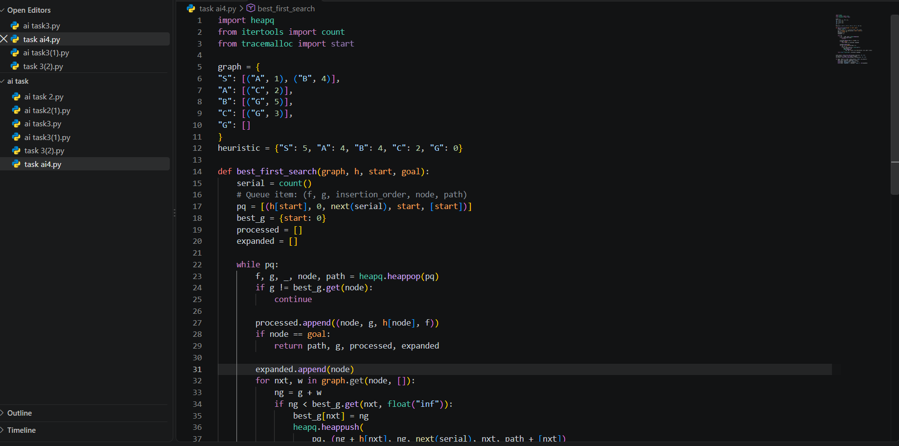
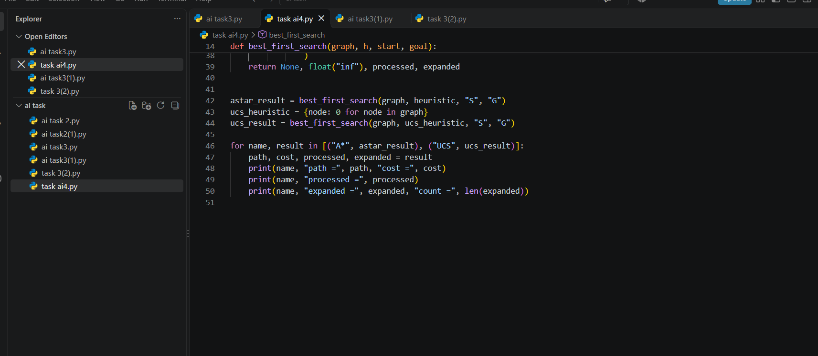
Output:
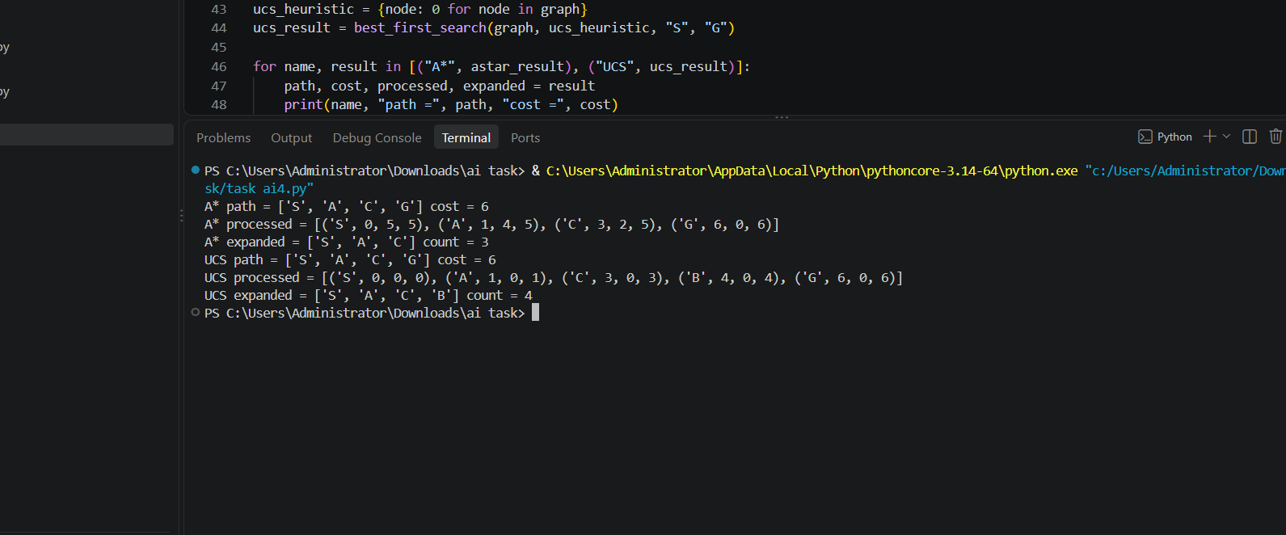

3. A* Run (Supplied Heuristic)
The priority is f(n)=g(n)+h(n). The supplied heuristic leads A* through S, A and C, then selects G.
Processed node | g | h | f | Frontier after processing (node:g,h,f) | Action
S | 0 | 5 | 5 | A(1,4,5), B(4,4,8) | Expand S
A | 1 | 4 | 5 | C(3,2,5), B(4,4,8) | Expand A
C | 3 | 2 | 5 | G(6,0,6), B(4,4,8) | Expand C
G | 6 | 0 | 6 | B(4,4,8) | Goal processed; stop
A* processed trace (including goal): S, A, C, G.
Expanded nodes (goal excluded): S, A, C. Expansion count = 3.
Returned path: S → A → C → G. Independent cost check: cost(S,A)+cost(A,C)+cost(C,G)=1+2+3=6.
4. UCS Control Run (h(n)=0)
With h=0, f(n)=g(n), so the priority queue selects the node with the smallest accumulated cost.
Processed node | g | h | f | Frontier after processing | Action
S | 0 | 0 | 0 | A(g=1), B(g=4) | Expand S
A | 1 | 0 | 1 | C(g=3), B(g=4) | Expand A
C | 3 | 0 | 3 | B(g=4), G(g=6) | Expand C
B | 4 | 0 | 4 | G(g=6 via C; G(g=9) not an improvement) | Expand B; proposed G cost 9 is worse
G | 6 | 0 | 6 | Empty after goal removal (any stale entries ignored) | Goal processed; stop
UCS processed trace (including goal): S, A, C, B, G.
Expanded nodes (goal excluded): S, A, C, B. Expansion count = 4.
Returned path: S → A → C → G. Independent cost check: 1+2+3=6.
5. Comparison
Algorithm | Processed trace | Returned path | Path cost | Expanded count (goal excluded)
A* (supplied h) | S, A, C, G | S → A → C → G | 6 | 3 (S, A, C)
UCS (h=0) | S, A, C, B, G | S → A → C → G | 6 | 4 (S, A, C, B)
6. Interpretation and Test Notes
Both algorithms return the optimal path S → A → C → G with total cost 6. A* expands 3 nodes, while UCS expands 4 nodes under the lab manual’s convention, because the supplied heuristic guides A* toward the goal before it needs to expand B. Goal G is processed and logged but not counted as expanded.
When B is processed in the UCS run, the alternative route to G would cost 4+5=9. Since the current best cost to G is 6, this candidate is not added as an improvement. A stale-entry check is included in the code so obsolete priority-queue entries are skipped.
Edge-case test: if start=goal (S to S), the algorithm should return path ['S'] and cost 0, with zero expanded nodes because the goal is processed before examining successors. The supplied graph has nonnegative edge costs, as required for the UCS control.
7. Conclusion
On this graph, A* and UCS find the same minimum-cost path and cost. A* expands one fewer non-goal node (3 instead of 4), demonstrating a measurable efficiency difference using the expansion-count convention specified in the lab manual.

